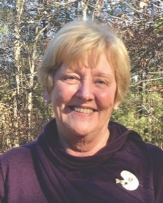

Sue Sheridan

Professional background:

I graduated from UMASS Amherst with a B.A. in Fine Arts. My resume shows that I have had a varied work history, teaching high school art, bookkeeping, administrative positions, and finally a career in the federal government. I worked first in the Department of Agriculture, and finally 25 years in the Social Security Administration, from which I retired. My career with Social Security included interviewing applicants for benefits and making decisions on eligibility, management positions in field offices, and finally as a management specialist serving the New England region in the human resources area.

Volunteer work:

My interest in the arts has led me to take on various roles including a 6 year term on the Franklin Cultural Council, president of the Franklin Art Association, and a current member of the Franklin Cultural Festival/District Committee. I also volunteered at the Franklin library teaching English as a second language.

FUSF:

Since joining 13 years ago I’ve served on the Hospitality Committee, the Fundraising Committee, as a Lay Minister, on the Board of Trustees, the Ministerial Relations Committee, as a choir member, and currently serve as chair of the Aesthetics Committee.

Search Committee:

I think I have the necessary skills to serve on this committee. I’m a good listener, and work well with others. I strongly believe in a collaborative approach toward reaching consensus. I have a strong work ethic and will commit to the process of choosing the best candidate for our congregation. It would be an honor to serve on the Search Committee.

