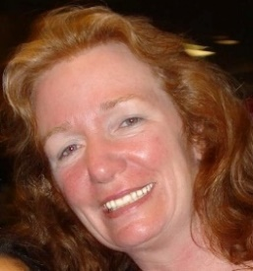

Elizabeth Randall

I live in Wrentham, MA with my husband, Doug and daughter Sarah. Both Doug and Sarah are also members of FUSF. We also have two beloved dogs, Teddy and Lilly.

I work on my own as an Interior Designer and Preservation Consultant. Previously, I worked at Harvard University for 22 years as a Construction Project Manager. After that I worked for Dean College managing some of their construction projects.

I have been a member of FUSF for about twenty years now. During that time, I served as President for three years and am now the Chair of the Welcoming Team. I have also taught RE many years and was a Junior Youth Advisor, along with my husband. I served on the Building Committee in various capacities when we were building the church and the RE wing.

During my time as President I oversaw the removal of the old house that was on the site, as well as dealing with a large sprinkler leak that caused the foyer to need major restoration.

I contribute to the church by organizing various events, including the Birthday Bash when we celebrated the tenth anniversary of the building, the end of the year party, Rev. Carol Rosine’s retirement event, the Miracle Sunday, and (unfortunately) many funeral services.

I would like to serve on the Search Committee because I feel that choosing the correct Reverend for our church is one of the most crucial ways that I could contribute to our community and I realize how important it is to find the right fit for us. I am an extremely organized person so I think that will help with all the paperwork moving forward. I have also had to interview many people in my job so I think I am good at understanding personalities quickly. Over the years, I have visited many other U. U. churches so I understand the U. U. community in a larger picture. I also know a great deal of history about our church and our congregants and can bring that knowledge to the process. I am admittedly not the best listener, but I think I am getting better at that, thanks in large part to being a part of this church. I also think I have a sense of humor, which could contribute to the process. (Though if you ask my 17 year old daughter, she would say that my sense of humor was whacked!)

