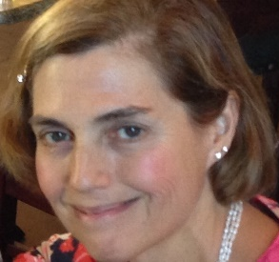
Jean Burke

My husband, Joe, who is recently retired from his career as a marketing executive for various technology companies and I will celebrate 36 years of marriage in July. We live in Norfolk with Cosmos, the elder Great Dane and Wesley, the Shorkie.

I have a B.A. in Music Performance from Arcadia University. In 2005, I completed the M.B.A. program in Global Management at The University of Phoenix Greater Boston Campus. In 2007, I completed the Certificate program in Theological Studies with an emphasis in Theology and The Arts
at the Andover Newton Theological School.

By profession, I’m a financial manager, trustee and investment advisor for the CHB Association and have served in this capacity for nearly three decades.

I’ve had years of experience performing with the EKK (Eine Kleine Konsort) quartet, taking their Recorder Goes To School program to elementary schools around New England to present to young and enthusiastic music students. Other areas of joyful activity and involvement include membership at Foxboro's Invensys YMCA and participation in The Norfolk Quill Writers Workshops, publishing in TNQ's Literary Journal for the past seven years. In 2016, I was asked to co- lead The Norfolk Quill.

I have been a member of FUSF for about 30 years. I maintained my FUSF membership during family job assignments to Munich, Germany and Greensboro, North Carolina. I have served as Franklin Interfaith Council Member, FUSF Board Member, Treasurer, Assistant to the Treasurer, LiveARTs Treasurer, and as a member of FUSF's Finance, R.E., Stewardship and Music Committees. I was a leading participant in the Capital Campaign to build the sanctuary, FUSF's "Miracle Sunday" to build the R.E. wing and got the ball rolling on our Planned Giving initiative.

My experience with FUSF includes lay-led summer services, teaching in the RE program, performing in FUSF's Special Music Segments, singing with the Universal Singers, writing with the poetry group, participating in the annual FUSF Community Art exhibits and running a film discussion group. Over the years, I’ve taken several Adult R.E. courses and my children went through RE and OWL programs.

