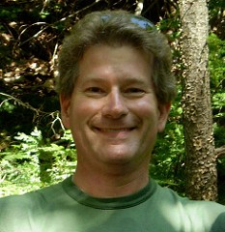
Rand Barthel

The basics:
Born: Missouri, 1956
Now live in: Mendon MA
Education: Harvard, B.A. Physics, 1978
Profession: Software Engineer
FUSF Member Since: 2000 (I think)
UU Since: early childhood
Social justice focus: Climate justice
Interests: singing, astronomy, sailing, hiking, camping

FUSF service: choir, 10+ years; Stewardship committee, 2004-6; 5 years treasurer of LiveARTS

Theological perspective:
80% humanist, 20% mystic. I don’t “hyphenate” my UUism with anything else. I revere the Source of All without personifying it, and believe it can be found wherever you choose to look.

What I could bring to the Ministerial Search Committee:
As a UU “lifer”, I have a strong allegiance to both FUSF and to the Unitarian Universalist movement as a whole. I’ve been a member of several UU congregations (of which FUSF is by far the best) which I think provides useful perspective. I have a strong grasp of UU history and of the place of UUism in the history of religious ideas. I am by nature diplomatic and inclined to seek consensus. I strongly believe that we have “good news” that the world needs to hear.

